**Topic:** Display of special characters

**Pre-requisite knowledge:** Basic LCD interfacing, displaying strings on LCD

**Components required:** Firebird V with 8051 main adapter board

**Basic Concept:**

* **What are special characters?**

A [character](http://www.webopedia.com/TERM/C/character.html) that is not a letter, number, symbol, or [punctuation](http://www.webopedia.com/TERM/P/punctuation.html) mark is known as a special character. These characters cannot be directly printed using keyboard buttons. They need to be made manually.

* The commonly used 16x2 [LCD](http://engineersgarage.com/content/lcd) can also display custom made characters besides numbers, alphabets & special characters. Any character can be made to appear on a 5x7 pixel matrix element without knowledge of its ASCII value.

The picture below shows how a character displays on LCD, as you can see one letter holds one 5x7 pixel matrix and corresponding pixels are set high in that matrix to make that letter appear. In this way we can display any impression on LCD by programming each pixel individually.

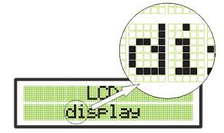

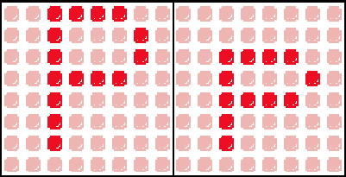

* A LCD is an arrangement of various 5x7 segment displays arranged in specific number of rows and columns so as to display more than one character at a time.
* A 16x2 LCD consists of 32 5x7 segment displays arranged in 2 rows and 16 columns allowing us to display 32 characters.

I hope now you are clear with the concept of character display on LCD. Now we will learn how to program to print these custom characters on LCD. So by writing program for individual segments we can display any character on the LCD.

For writing program first let us know memory mapping in a LCD.

**MEMORY MAPPING:**

The memory of the LCD divided into three parts:-

* DDRAM:-Display data ram is used for displaying character. A maximum 80 character can be stored in this out of which only 32 characters are visible.
* DDRAM memory address starts from 0x80 to 0xA7 in first row and 0xC0 to 0xCF in second row.
* CGROM:-This is the memory address where all the predefined patterns are stored.
* The patterns are drawn in this memory area during the time of manufacturing.
* The patterns are stored such that their memory address is equivalent to their ASCII code.
* CGRAM:-This area of LCD’s memory is used when the user wants to do his own animation on the LCD. Like: heart, smiley etc.

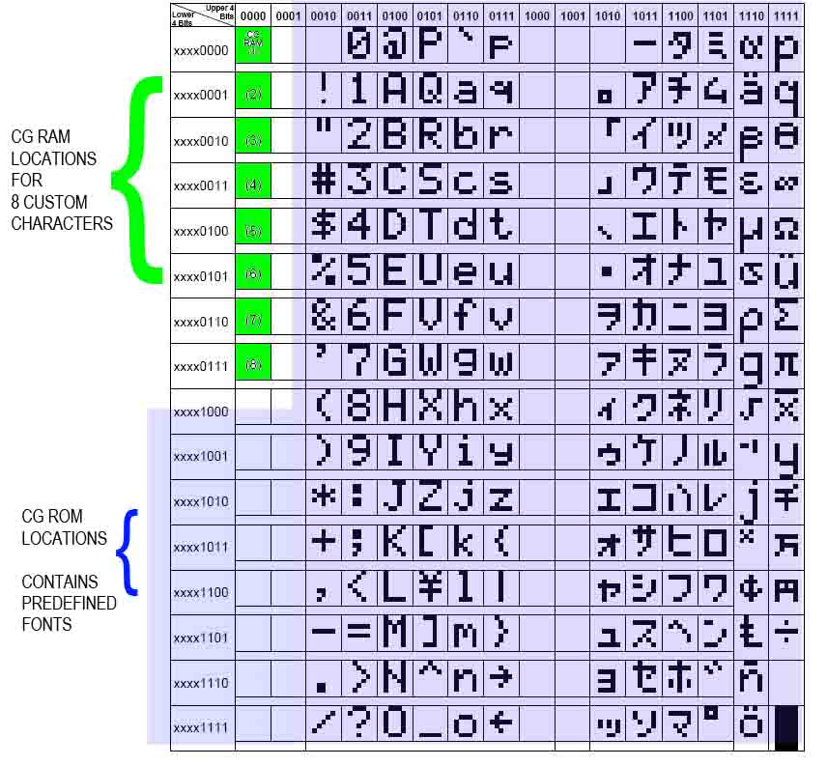

Now to design our own special characters we have to store it in CGRAM. There are 8 symbol locations where a custom character can be stored as shown in the following table. These locations will have a particular bitmap layout corresponding to the custom character.

When the controller receives an ASCII code in the range that's mapped to the CG RAM, it uses the bit patterns stored there to display a pattern on the LCD. The concept here lies in the fact one can write to the CG RAM, thereby defining one’s own graphic symbols. Each byte of CG RAM is mapped to a five-bit horizontal row of pixels, and LCD characters are typically eight rows high, so 64 bytes of CG RAM is enough to define eight custom characters. These characters correspond to ASCII codes 0 through 7.

When an LCD is first powered up, CG RAM contains random garbage bits. If necessary, CG RAM may be cleared by writing 00 into each CG RAM cell.

**An example to display arrow sign is given below:**

To display an arrow sign, the bitmap values are mapped to a base address location, say 64 (ASCII code 0).

The symbol locations with their base addresses are given below:

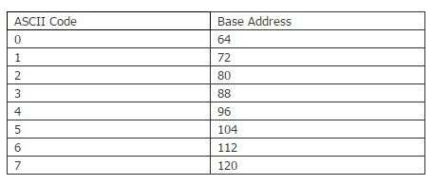

This is achieved by first sending the address location (64) to LCD command register. Next, the bitmap values (0, 4, 2, 31, 2, 4, 0, 0) are sent to the LCD data register. Now the arrow sign gets stored at the first address. Now whenever this symbol is to be displayed, its location needs to be sent to the command register of LCD.

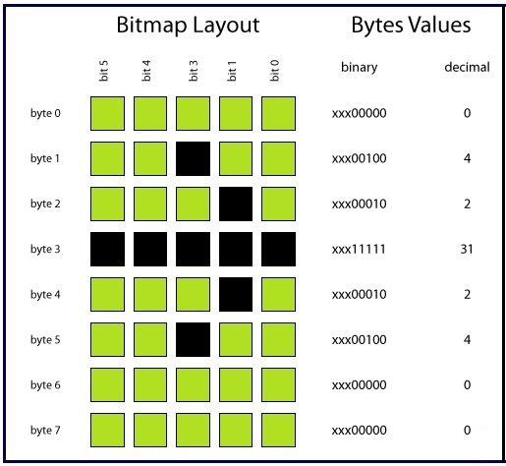

In order to draw pattern of this shape, following algorithm is used:

1. Initialize the LCD
2. Clear LCD screen
3. Store this shape in CGRAM by giving appropriate commands
4. Set the cursor on the desired location where you want to display character
5. Display it on the screen by giving appropriate command.

* **Code for the above and for many other special characters is given in the experiments folder.**